**Yammer Sign Up Guide**

Update on: 5 Aug 2014

1. Login at email.cpce-polyu.edu.hk, click on the ‘Yammer’ button



2. Input your staff email address, click the ‘Sign up’ button



3. Received email from Yammer with title ‘Activate your Yammer Account’, in the email content, click ‘Complete Signup’ button

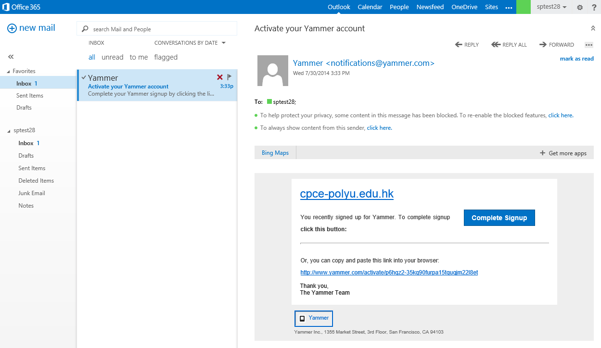

4. Enter the required information and ‘Password’ to login www.yammer.com directly via web browser or Yammer mobile app

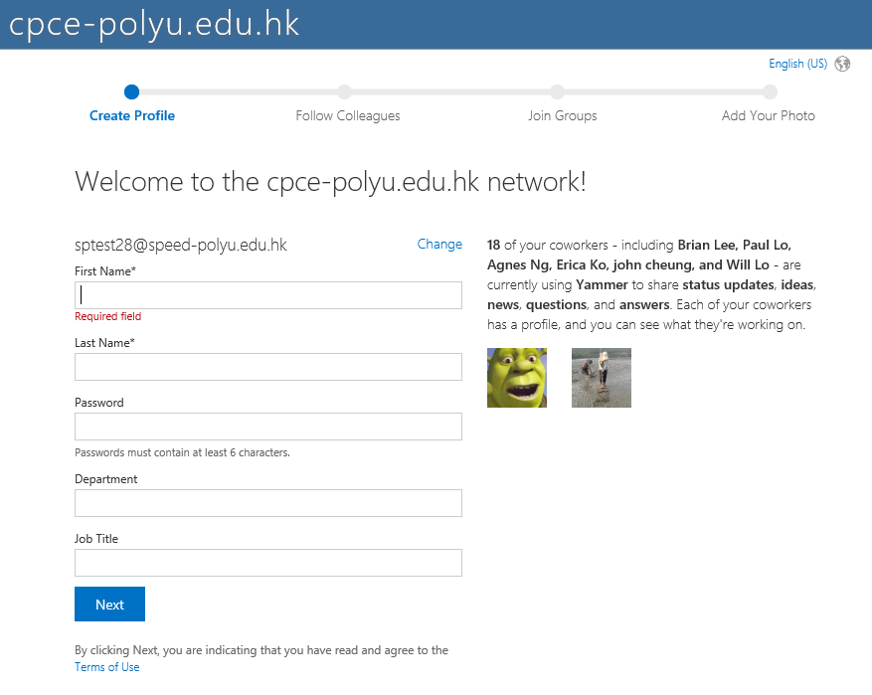

5. Add colleagues if you want

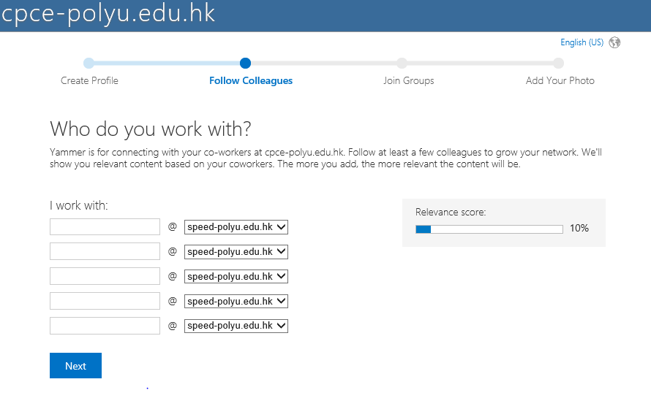

6. Add your profile photo

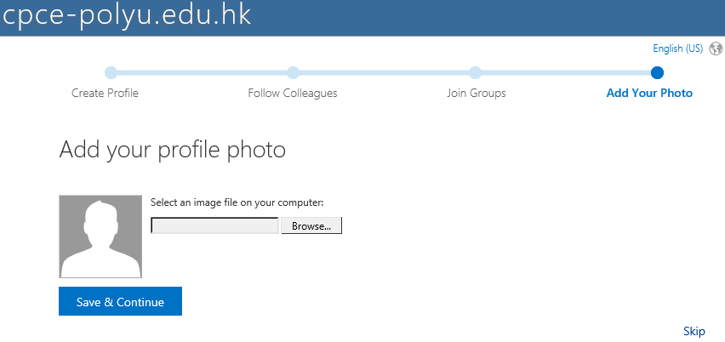

7. Download and install the Yammer Notifier in your desktop if you want



9. View your Yammer home page

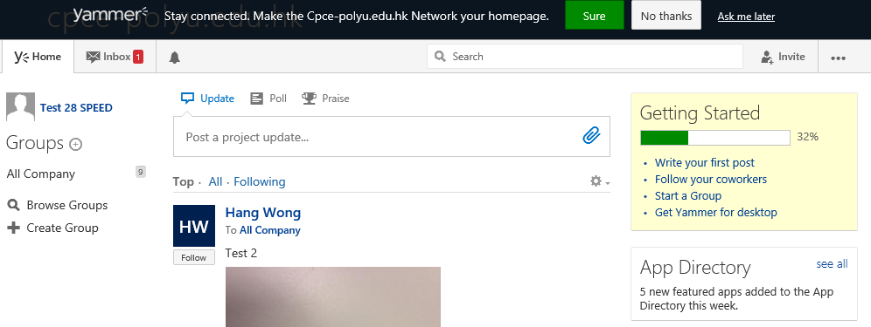

10. Download the Yammer App in the Play Store and Apple Store in your mobile device