Yammer User Guide

Table of Contents
Section 1 – First Steps 2
1.1 Welcome to Yammer 2
1.2 Filling your Profile 3
1.3 Other settings and Preference in the profile page 6
Section 2 – Layouts & Main pages 8
2.1 Home 8
2.2 Inbox 10
Section 3 – Feature pages 12
3.1 Groups - View available Groups & Join it 12
3.2 People – People directory & Follow person wanted 12
3.3 Files - Sharing files and Checking shared files 13
3.4 Apps – enhanced features thru various apps 14
3.5 Your own FEED and Profile 15
Section 4 – Mobile apps supported 17
Section 5 – Hints & Tips 18

(Date: 20 Aug 2014)

Section 1 – First Steps

1.1 Welcome to Yammer
When Yammer account is now set up and active. You can continue to browse the discussion groups available to you, by clicking Browse Groups, indicated by the red circle labeled 1.
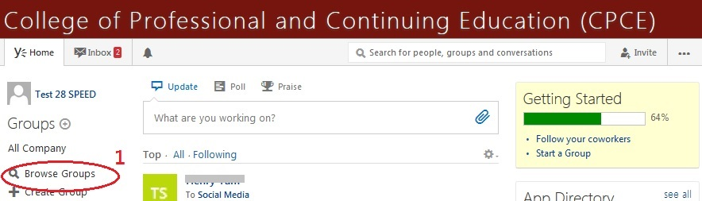
And you can choose the Groups available to you
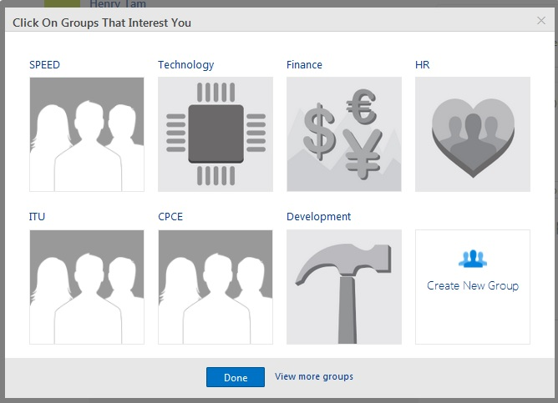

For your first group, the All Company is suggested. Yammer users across college (CPCE/SPEED/HKCC) use this group to share ideas on how to use Yammer, and also as a first point of contact to help orient new users.

1.2 Filling your Profile
Once you have logged in to the Yammer network, you can go back and edit your account information if necessary. You can do this by first clicking on the  icon in the upper right hand corner, and selecting the “Edit Profile” option.
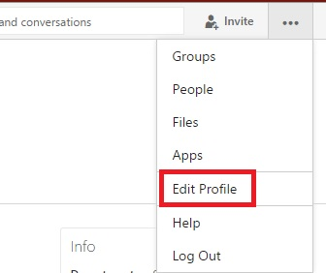
Or thru “MyFeed” and profile info page as below:
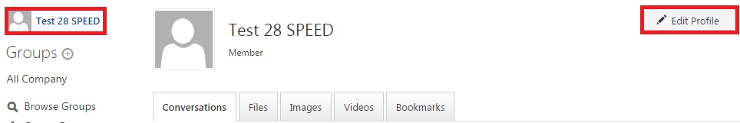
Once you are on the Edit Profile screen, you will see various areas you can change – starting with the Basics. You would come here to change your profile picture any time you wish.
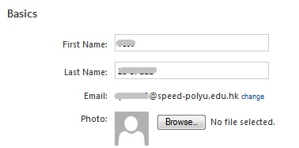
Updating your profile is a great way for people to learn more about you. As soon as you can, enter your Bio, Job Title and Department as well as other information you would like to share with others in the CPCE network that might be interested in learning more about you and what you do within the organization.
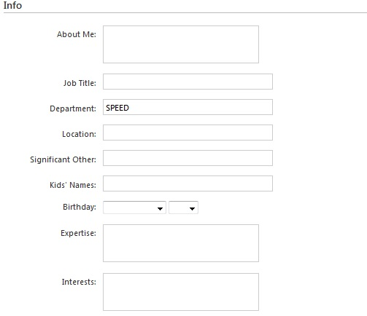
Add Contact information about your work, your personal life, anything you want people to read. There are also links for Social Media (like Facebook and LinkedIn) if you also use those.
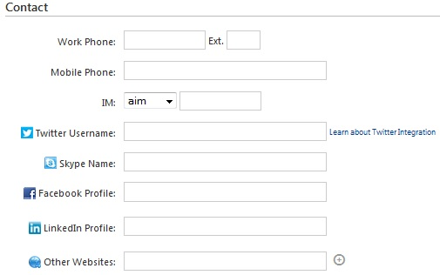
Or optional add your previous Work and Education Info
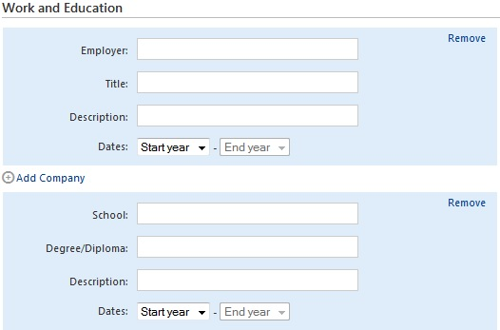

1.3 Other settings and Preference in the profile page
In the profile page, a few of the items on the navigation bar (Org Chart, Networks, My Applications, Notifications, Preferences) can be set
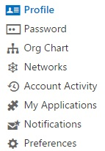
You can revoke the Application (Apps)
The “Notifications” here means notification by email

One type of email that Yammer will send you is called a “Active Digest”. The digest compiles the most active content on your network and varies based on your Yammer activity. You can choose to completely turn this email off or have Yammer send it to you on a daily or weekly basis. If you choose the daily option, Yammer will not send you a digest on the weekend.
Another type of email that Yammer will send “Real-time Emails”. There are options for real time emails. You can choose to have Yammer instantly email you when a few different things happen on your network. For example: 1) You can sign up to receive emails when you receive a message in your inbox, you get a new follower, someone invites you to a group, someone likes a message you posted, or tips and important updates about Yammer. 2) To tick the following groups that Yammer notifies you about new activity.

Active Digest
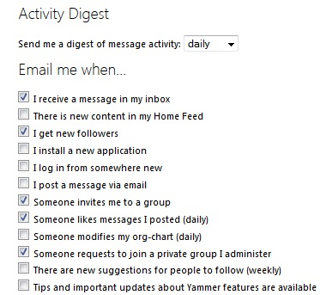
Real-time Emails

“Preferences” page will let you change the Publisher settings & Timezone.
You should change Timezone to “Hong Kong” in our college.
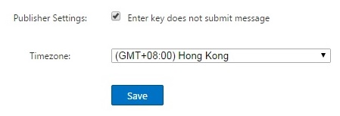

Section 2 – Layouts & Main pages

2.1 Home
The most basic feature that Yammer has to offer that we will cover first is your Feed. Your feed is an immediate overview of everything that is going on within the CPCE Network. People could be scheduling meetings, sharing links, or just asking questions. All of this information will be found under the “Yammer Home” section.
Here is the layout:
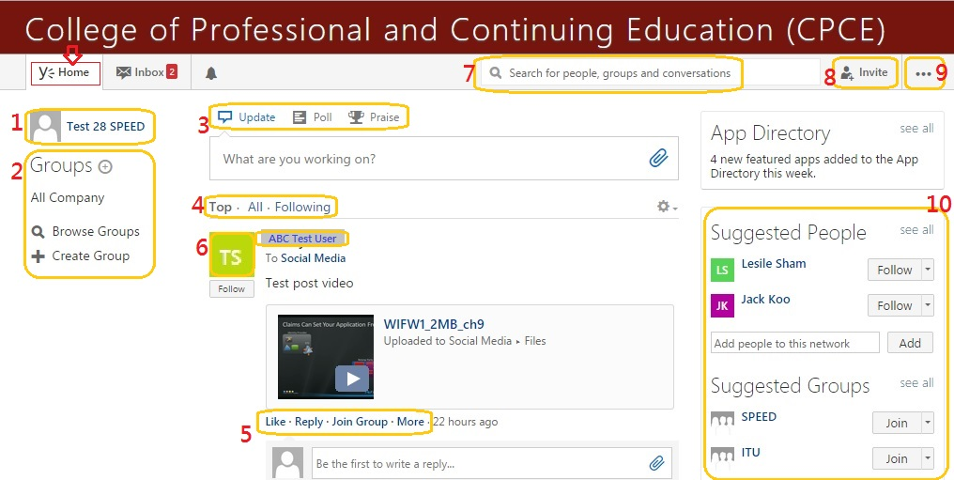
- Click on your image or username to see the conversations you're involved in, your details and who you're following. You can then click on 'Edit Profile' to change your details, photo, password, email notification settings and more
- Down the left side of the page there's a list of the groups you've joined. Click on any group to see their latest conversations. You can click on the '+' sign to create your own group.
- Click here to Post - 'Update conversation', 'Poll', 'Praise' someone.
- There are three different ways to view messages in your news feed: 'Top' orders the conversations in order of most relevant to you (as deemed by Yammer), 'All' is every conversation ordered with the ones with the recent comments at the top, and 'Following' is conversations posted only by people you are following.
- To participate in a conversation, you can 'like' a post, which will cause the words "[your name] likes this" to appear under the post. You can also 'reply' and add your own comment or share the post with a private group. Clicking on 'more' will give you more options.
- View profiles - click the [head icon] or [username] to know your coworkers by viewing their profiles and maybe you’ll learn something new about them. If everyone fills out a profile, it helps people connect. Fill out yours, check out others to start connecting with people throughout your organization
- Single search bar - it find everything you need including people, groups, conversations and even information in other business applications integrated in yammer
- Clicking on the headshot icon [invite] will give you the options to invite new members to yammer network.
- Clicking on the “…” icon will give you a menu about “Group, People, File, Apps, Edit Profiles, Help” pages and Sign-out” button.
- Yammer will suggest people for you to 'follow', which means their posts will appear in the 'following' tab at the top of your newsfeed. You can also follow people by hovering over their name when you see it in your newsfeed, and clicking 'Follow'. And Yammer will suggest groups for you to ‘join’, which means the group you may interest.

2.2 Inbox
Other than the Feed, another way to get information to people within the Network is by sending a Private Message (PM). PM are messages only sent to you. Others may be copied on a message, very similar to e-mail, but none of this information will ever be shown on the Feed.
You can view the private message in your inbox shown below:
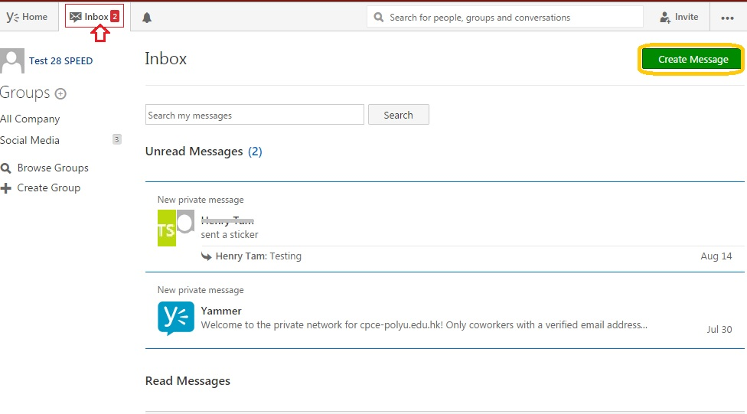
Send a private message to someone (a group or particular one), you simply click
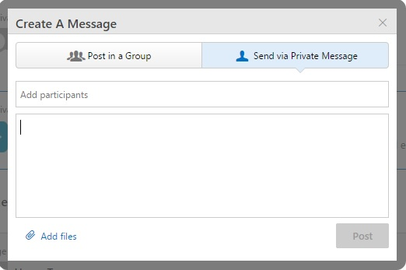

2.3 Notifications
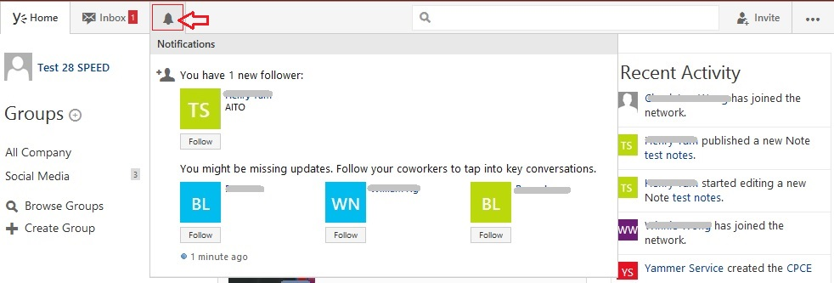
Notifications is a separate feed, accessible from the left navigation panel that highlights the activity on Yammer that is most relevant to you. For example, when someone @ mentions you, follows you, or replies to your message, you will receive a notification.

The Notifications feature is designed to call your attention to messages and other actions on Yammer that directly impact you. To alert you of this activity, there is a counter next to the Notifications feed that increases as you receive new notifications. Once you review the stories in your Notifications feed, the counter will clear.

Section 3 – Feature pages

3.1 Groups - View available Groups & Join it
One of the most powerful features of Yammer is the ability to create and join groups. The CPCE Network currently has many public groups. To view the directory of all groups in the CPCE Network, click on Groups in the right hand navigation button. If you feel that you can benefit being a part of any of these groups, make sure to join them. You can do so by clicking the “+ Join” button next to the group description.
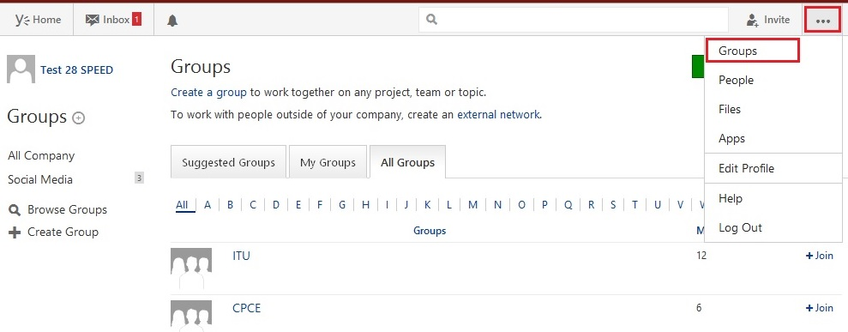
Once you are joined into a group, you can see all of the Feed information within that group. It will show up right on your main Feed, and you can post to that group simply by selecting it.
We recommend that the first group you join is “Yammer User Group” Group. Navigate to this by clicking “Y” in the alphabetic navigation or type in “Yammer User Group” in the search bar. The “Yammer User Group” is intended for all users of Yammer, both new and experienced, to share tips, best practices as well as ask questions within the yammer community.

3.2 People – People directory & Follow person wanted
In this page, you can view all people available on the yammer network in the People Directory
And follow the person you wanted by click
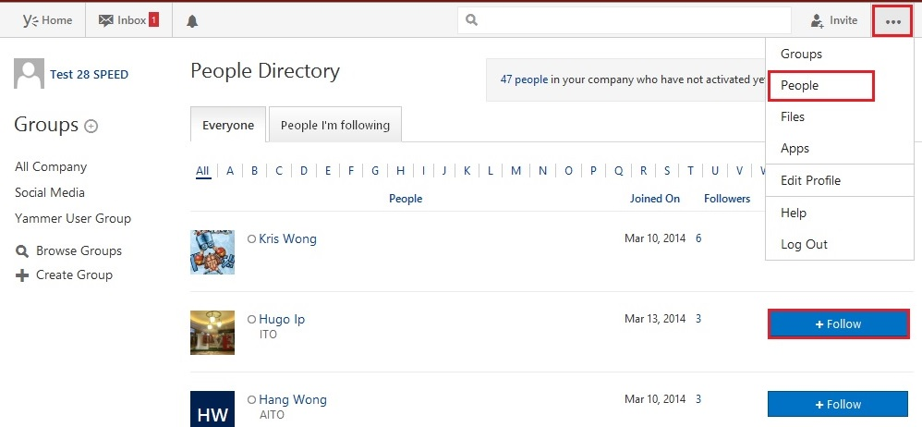

3.3 Files - Sharing files and Checking shared files
Yammer also allows you to share documents with colleagues. Make sure that the documents you share are interesting for your colleagues and post them to the correct spot. This usually means that documents should be posted to specific groups. If a may be interesting to everyone, then you can post it as an update, but do so sparingly.

3.3.1 Sharing files (Documents, Images, Video etc.)
Choose the GROUP with which you wish to share the document.
Under “What are you working on?” bar, describe why this document is interesting – but DO NOT press Enter!
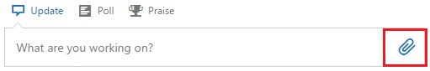
And click , choose the method to attach files you would like to share and the maximum file size is 5GB.
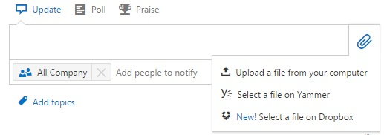
Then click on . Now you share the files/documents successfully.

3.3.2 Checking shared files
All of the documents your colleagues have shared can be found in the right menu under -> Files

3.4 Apps – enhanced features thru various apps
Yammer can be accessed through a web browser interface, which has the richest set of features, or through a desktop or mobile application.

You can download a desktop or mobile application at any time by clicking the Apps link in the menu at the upper right of any Yammer screen.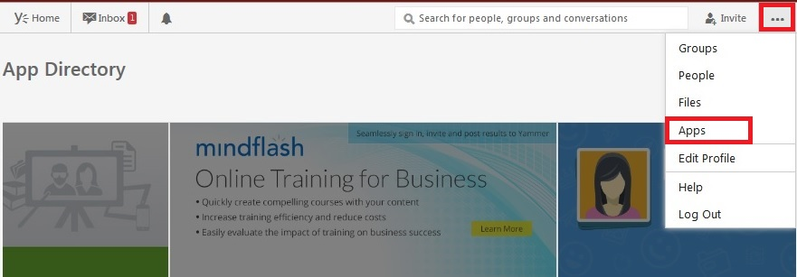
And Click and in pop-up window, click to install it.
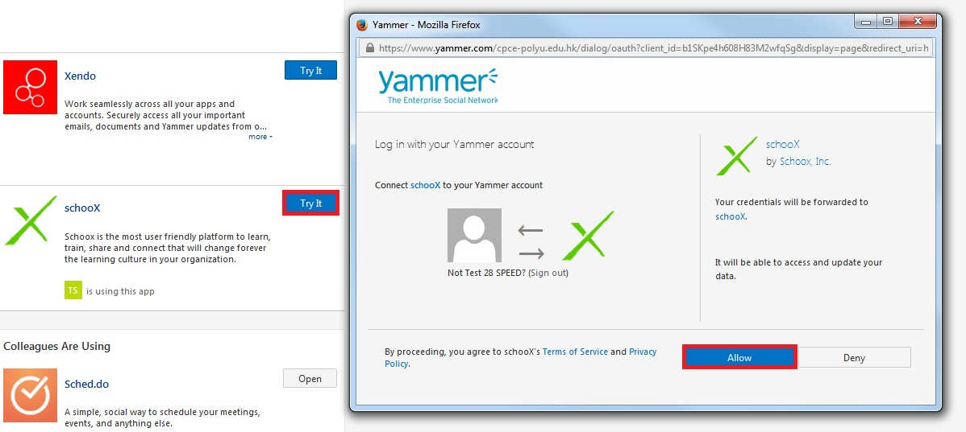
Or
You can download the Apps thru yammer website or app stores

3.5 Your own FEED and Profile
You can review the user feed (conversation, files, images, videos, link, bookmark etc.)(Shown as label 1)
Show your info & connect (Shown as label2)
Editing your own profile in this page. (Shown as label 3)

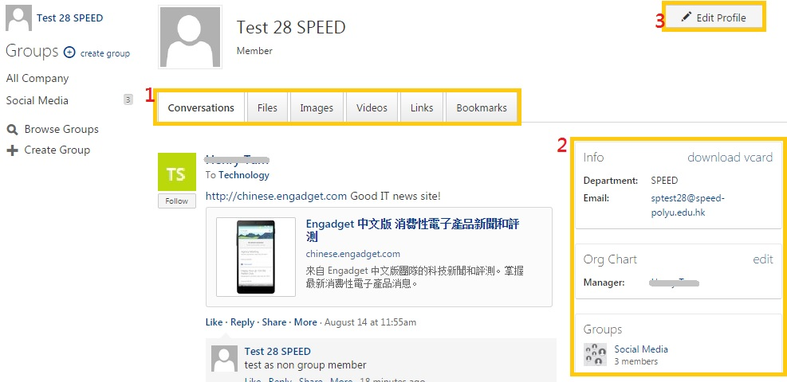

Section 4 – Mobile apps supported
Yammer support various Mobile Platform included Android devices, iPhone, iPad, Windows Phone
You can search and download them thru their app store or thru the logout page of yammer (as below).
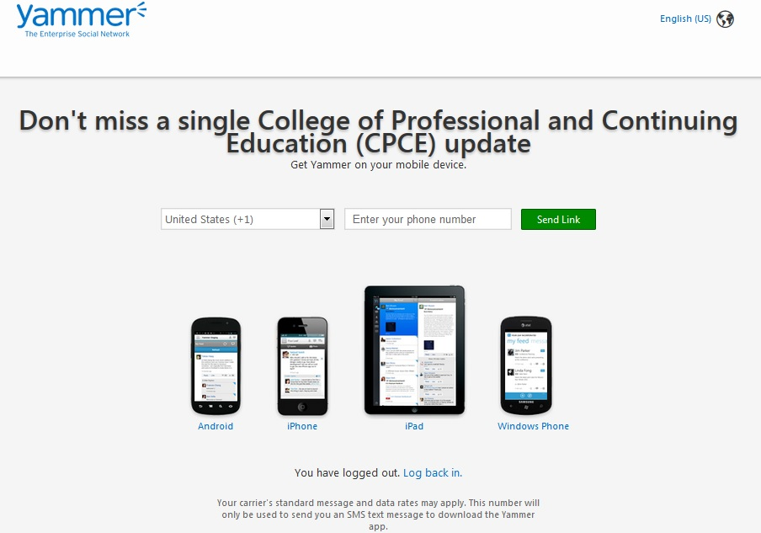

Section 5 – Hints & Tips
- “All Company”
The "All Company" feed is available under your groups list. This shows you posts from everyone within the college Yammer network.

- “Home – Top, All, Following”
The "Home" tab will show you the latest posts from colleagues in all of the groups you are a member of. When viewing the "Home" feed, you have the choice of viewing the "Top", "All" or "Following" posts. "Following" refers to people you are following only, not those who are following you.

Top Conversations
This is an algorithmic feed of the conversations most relevant to you, based on what you subscribe to and your interactions with Yammer network content.

All Conversations
These are all the conversations to which you have access within your company network.
You can toggle between filters via the drop-down menu. Top Conversations is the default, but you can always switch back to All or Followed Conversations, as well as Sent messages, Bookmarks, Likes & the “Edit Who I’m Following” tool.

Following Conversations
These are the conversations you actively subscribe to, including the users and Topics you follow, and your Group memberships.

- “#HASH TAGS & TOPICS”
Hash tags (#tags) are a way of marking what the message is about. You can tag with #help because it is helping someone or you can tag it with #yammertip because you are answering someone’s request for #help with a tip. When you post the message it becomes a hyperlink and if you click on the #tag you will see all the tagged public posts.
A hash tag allows you to follow topics rather than people. So you might not be interested in me (so you don't follow me) but you are interested in the topic of (e.g. #sportsday) so you click on they #tag and you will see a 'follow' button click it to follow any posts (by people you don't follow) that have been tagged.
Following TAGS (TOPICS)
This is a highly recommended way to find new members and new ideas. Simply click on any tag in a message you are interested in (such as #leadership), it take you to the topic page. Here you can follow the topic so when any one posts a message with #leadership it will appear in your ‘My feed’.

- “@MENTION”
Post a message: — a question, an update on your current project, an interesting article that others will benefit from. Don’t be afraid to share content from anywhere. If you see an interesting article on your company or a competitor – you can bet your colleagues will want to know. Post to a group if the content is specific; post to the wider network if you want others to serendipitously discover it. You can also @mention (public mention) colleagues to draw them into the conversation.
Or
TAGGING
You can "tag" a colleague in your post. To do this, type their name in your post and a list of options will appear. Select their name and continue with your message. This will notify them of your post.

- “File attachments and related restrictions”
- The number of files you can attach an article without restriction.
- Maximum size for a single file attachment is 5GB.
- You can attach different files, such as. PDF files, image files, video files, Microsoft Office files, and so on. ICON display depends on the file type of the attachment.
- Any non-image file attachments is visible are as link under message. Users can click the link to download the file.
- Respect of any annex to the thumbnail image in the [your message] under [visible]. To view the video, users click the thumbnail. When users view images, they can click the download link to download a copy of the image.
- Any video attachments is visible as thumbnail under your message. Users can click the thumbnail to watch the video inline. Supports the following video types:
.wmv, avi, .mpeg, .3GP, .flv, .mov, .mp4, .mpg, .ogm, mkv, ogv, and ogg

