

Work-Integrated Education System

User Manual

  - August 2020
  - Version 1.00

Document Revisions
Date | Version Number | Document Changes
09-July-2020 | 1.0 | Initial Draft

Table of Contents
1. Introduction 5
2. Signing In 6
3. As ‘Student’ 7
3.1 Landing Screen 7
3.2 Header Navigator 8
3.2.1 Changing the font size 8
3.2.2 Updating the student profile 8
3.2.3 Logout WIE System 9
3.3 Filtering 10
3.4 View WIE Forms 11
3.5 Apply WIE Forms 11
3.5.1 WIE01 Proposal Form 11
3.5.2 WIE02 Log Sheet 12
3.5.3 WIE03 Reflective Learning Statement 14
3.5.4 WIE04 Prior Work Experience 15
4. As ‘WIE Advisor’ 17
4.1 Landing Screen 17
4.2 Header Navigator 18
4.2.1 Changing the font size 18
4.2.2 Logout WIE System 18
4.3 View Navigator 18
4.3.1 Dashboard 19
4.3.2 Student 20
4.3.3 eForm 23
4.4 Approve / Reject WIE Forms 25
4.4.1 WIE01 Proposal Form 25
4.4.2 WIE02 Log Sheet 26
4.4.3 WIE03 Reflective Learning Statement 27
4.4.4 WIE04 Prior Work Experience 28
5. As ‘Office Admin’ 30
5.1 Landing Screen 30
5.2 Header Navigator 31
5.2.1 Changing the font size 31
5.2.2 Logout WIE System 31
5.3 View Navigator 32
5.3.1 Dashboard 32
5.3.2 Student 33
5.3.3 Programme 35
5.3.4 eForm 36
5.3.5 Tool 42
6. As ‘Programme Leader’ 49
6.1 Landing Screen 49
6.2 Header Navigator 50
6.2.1 Changing the font size 50
6.2.2 Logout WIE System 50
6.3 View Navigator 50
6.3.1 Student 51
6.3.2 eForm 54
7. Appendix 56
7.1 Abbreviation and acronyms 56
7.2 Import Excel Template 57

Introduction
The Work-Integrated Education (WIE) system has been developed in the web platform in order to provide a simple, convenient and comfortable platform for students to apply online WIE forms and check its status anytime and anywhere. Also, it helps to minimize common mistakes and unfilled items on a traditional paper form. The accuracy and quality of application data will be improved and the administrative process time can be reduced.
Currently, 4 WIE application forms are available:
WIE01 : WIE Proposal Form
WIE02 : WIE Log Sheet
WIE03 : Reflective Learning Statement of WIE
WIE04 : Application for Recognition of Prior Work Experience

Signing In
To access WIE system,
- Open your preferred web browser and navigate to https://copacethkpu.outsystemsenterprise.com/work_Integrated_Education

- Type your CPCE account and password in the appropriate fields and then click the ‘Sign In’ button.
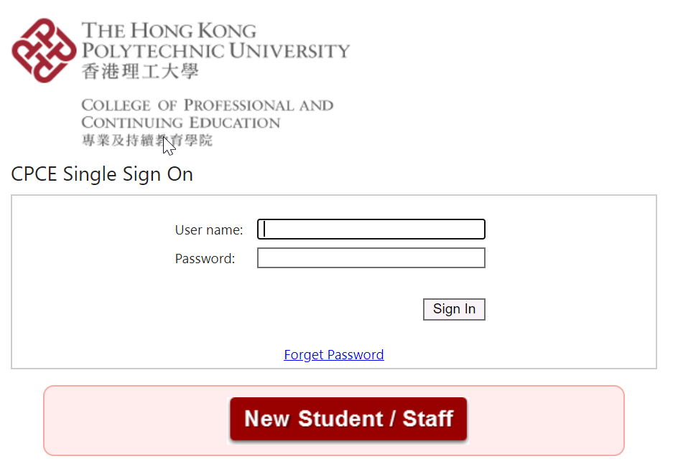
Once confirmed, you will be taken to the WIE landing page depending on your role (Student / WIE Advisor / Office Admin / Programme Leader).

As ‘Student’

Landing Screen
Once login successfully, the student landing screen will be shown as below.
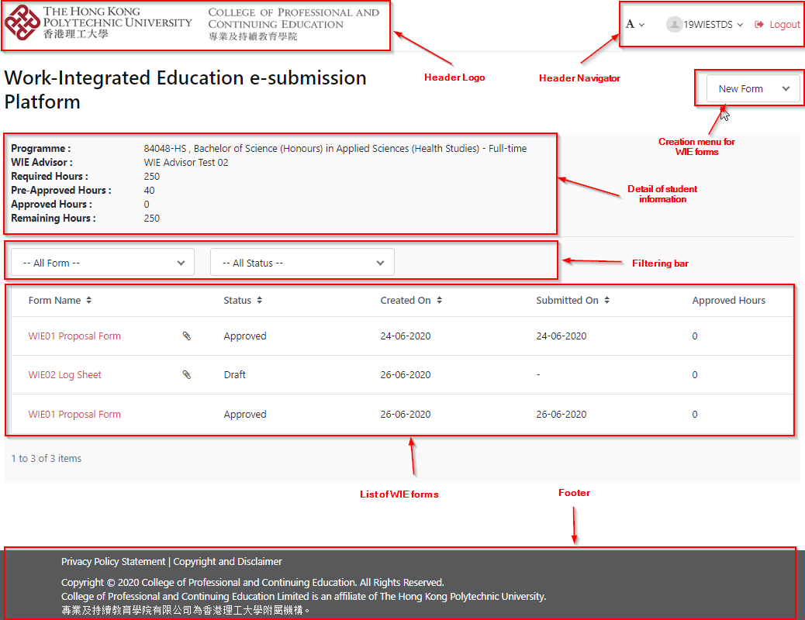
Header Logo | Logo of The Hong Kong Polytechnic University and The College of Professional and Continuing Education are displayed.
Header Navigator | To change font size, browse student profile and logout.
Creation menu for WIE forms | To submit WIE01, WIE02, WIE03 or WIE04 form if applicable.
Detail of student information | To display student’s programme, WIE Advisor, Required WIE hours, Approved WIE hours and so on.
Filtering bar | To select the form name and status for filtering
List of WIE forms | To display the list of WIE application forms
Footer | To state the privacy policy, copyright and disclaimer.

Header Navigator

Changing the font size
- To click the icon, the pulldown menu is shown.
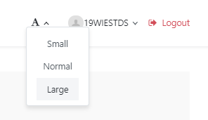
- You may change the font size by clicking ‘Small’ or ‘Large’ option

Updating the student profile
- To click on your student number, the pulldown menu will be shown
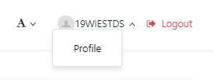
- To click ‘Profile’, the student profile will be displayed.
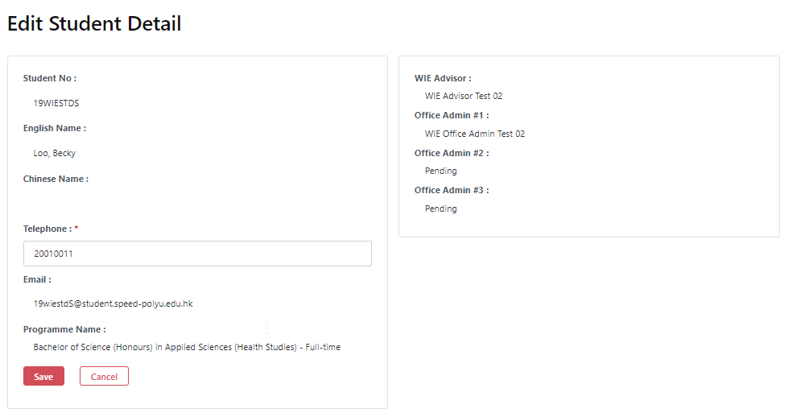

- You may modify your contact phone number and then click the ‘Save’ button to update it. Otherwise, click ‘Cancel’ button to close without saving.

Note: the ‘Student Portal’ reminder will be prompted if the phone number is changed. If students have their phone number changed, they should make the changes in my.SPEED as well.

Logout WIE System
To click for signing off the WIE system.
Once signing off successfully, the below screen will be shown. For security reasons, please close all browser windows.
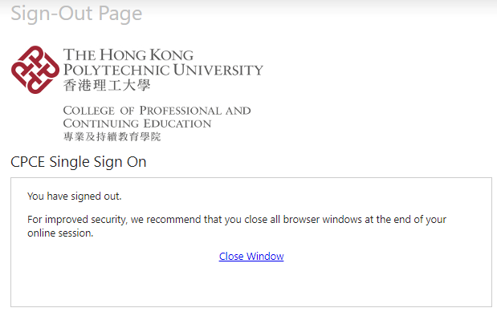

Filtering
To easily view the desired list of WIE forms, two filtering options are available.
Filter Options | Values
WIE form name | All Forms  WIE01 Proposal Form  WIE02 Log Sheet  WIE02 Reflective Learning Statement  WIE04 Prior Work Experience
Status | All Status  Draft  Submitted  Approved  Rejected  Re-Submit  Completed  Non -Completed

- Select ‘WIE01 Proposal Form’ in the ‘WIE Form’ filtering option if you want to view WIE01 application forms only.

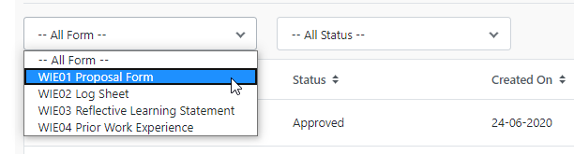

- The list of WIE forms will be updated accordingly.

View WIE Forms
- In the list of WIE forms, please click the required Form Name.
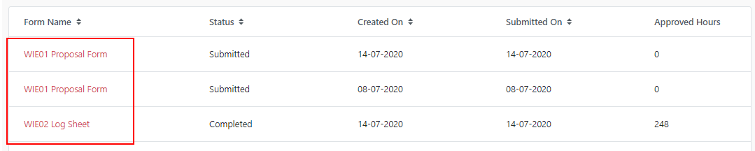

- Then, the form will be opened and you can take appropriate actions.

WIE Applications

WIE01 Proposal Form
- Starting applying for WIE01 by clicking the option ‘WIE01 Proposal Form’ under the “New Form” menu.
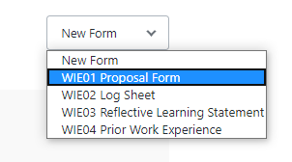

- Please fill in all mandatory fields before submission. In case that you cannot input all data at this moment, you can click ‘Save as Draft’ button to save it without submission.

- Once all information is entered, you can click ‘Submit’ button to submit it. If any data is invalid, the system will prompt the error message. Please correct them accordingly.

- If submission is successful, the status will be updated to be ‘Submitted’ and the form will be passed to WIE Advisor for approval. A notification message will be sent to your mailbox.

- Once WIE Advisor has approved or rejected your application, you will receive the notification message about the result.

- If it is rejected, you can amend the form or provide more supporting documents by clicking the ‘Re-submit’ button.
Button | Description
Submit | To submit it for WIE Advisor’s approval
Save as draft | To keep it as a draft without sending the form
Re-Submit | To submit the application again if it is rejected
Delete | To delete the draft application form if it is no longer needed.
Cancel | Close without saving

WIE02 Log Sheet
- Open a new WIE02 application form by clicking the option ‘WIE02 Log Sheet’ under the “New Form” menu.
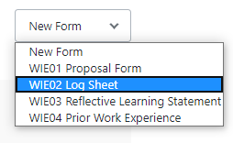

- To add a new job entry by clicking  at the bottom of form.

- The list of jobs submitted in the Proposal Form will be displayed. Please click to provide further information.

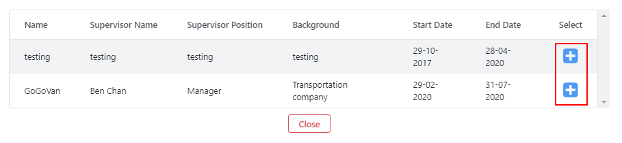

- Please fill in all mandatory fields before submission. In case that you cannot input all data at this moment, you can click ‘Save as Draft’ button to save it without submission.

- Once all information is entered, you can click ‘Submit’ button to submit it. If any data is invalid, the system will prompt the error message. Please correct them.

- If submission is successful, the status will be updated to be ‘Submitted’ and the form will be passed to WIE Advisor for approval. A notification message will be sent to your mailbox.

- Once WIE Advisor has approved or rejected your application, you will receive the notification message about the result.

- If the job entry is rejected, you can amend your entry or provide more supporting documents by clicking button at that job entry. After that, you can submit it again.

Note: Only one WIE02 Log Sheet can be created.

Button | Description
Submit | To submit it for WIE Advisor’s approval
Save as draft | To keep it as a draft
Cancel | Close without saving

WIE03 Reflective Learning Statement
- To open a new WIE03 application form by clicking the option ‘WIE03 Reflective Learning Statement’ under the “New Form” menu.
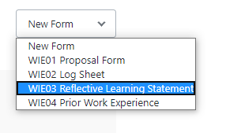

- Please fill in all mandatory fields before submission. In case that you cannot input all data at this moment, you can click ‘Save as Draft’ button to save it without submission.

- Once all information is entered, you can click ‘Submit’ button to submit it. If any data is invalid, the system will prompt the error message. Please correct them.

- If submission is successful, the status will be updated to be ‘Submitted’ and the form will be passed to WIE Advisor for approval. A notification message will be sent to your mailbox.

- Once WIE Advisor has approved or rejected your application, you will receive the notification message about the result.

- If it is rejected, you can amend data or provide more supporting documents by clicking ‘Re-submit’ button. After that, you can submit it again.

Note: Only one WIE03 Reflective Learning Statement is required.

Button | Description
Submit | To submit the WIE03 for WIE Advisor’s approval
Save as draft | To keep it as a draft
Re-Submit | To submit the application again if it is rejected
Cancel | Close without saving

WIE04 Prior Work Experience
- To open a new WIE04 application form by clicking the option ‘WIE04 Prior Work Experience’ under the creation menu.
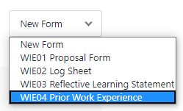

- Please fill in all mandatory data before submission. In case that you cannot input all data at this moment, you can click ‘Save as Draft’ button to save it without submission.

- Once all data have been inputted, you can click ‘Submit’ button to submit it and the validation will be taken according. If any data is invalid, the system will prompt the error message. Please correct them.

- If submission is successful, the status will be updated to be ‘Submitted’ and pass it to WIE Advisor for approval. Notification message will be received at your mailbox.

- Once WIE Advisor has approved or rejected it, you will receive the notification message to acknowledge its result.

- If it is rejected, you can amend data or provide more supportive documents by clicking ‘Re-submit’ button. After that, you can submit it again.

Note: WIE04 Prior Work Experience can be created by SPEED Stage students before week 6 of semester 1

Button | Description
Submit | To submit it for WIE Advisor’s approval
Save as draft | To keep it to be draft
Re-Submit | To submit the application again if it is rejected
Delete | To delete the draft application form if no need anymore.
Cancel | Close without saving

As ‘WIE Advisor’

Landing Screen
Once login successfully, the WIE Advisor landing screen will be shown as below.
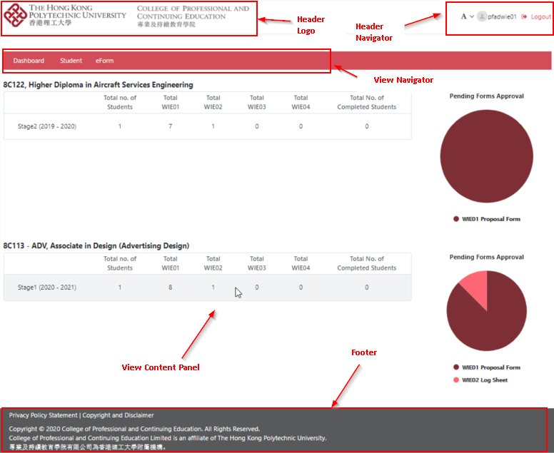
Header Logo | Logo of The Hong Kong Polytechnic University and The College of Professional and Continuing Education are displayed.
Header Navigator | To change font size, WIE Advisor’s name and logout.
View Navigator | To navigate the dashboard, student and eForm view content
View Content Panel | To display the associate view content
Footer | To state the privacy policy, copyright and disclaimer.

Header Navigator

Changing the font size
- To click the icon, the pulldown menu is shown.
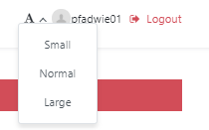
- You may change the font size by clicking the ‘Small’ or ‘Large’ option.

Logout WIE System
To click for signing off the WIE system.
Once signing off successfully, the below screen will be shown. For security reasons, please close all browser windows.

View Navigator
There are 3 view navigators - Dashboard, Student and eForm.

Dashboard
- To access the dashboard, please click ‘Dashboard’ in the view navigator.

- A summary of submitted forms under your programme will be illustrated in the left panel and the pending approval forms will be shown on the right panel as pie chart.
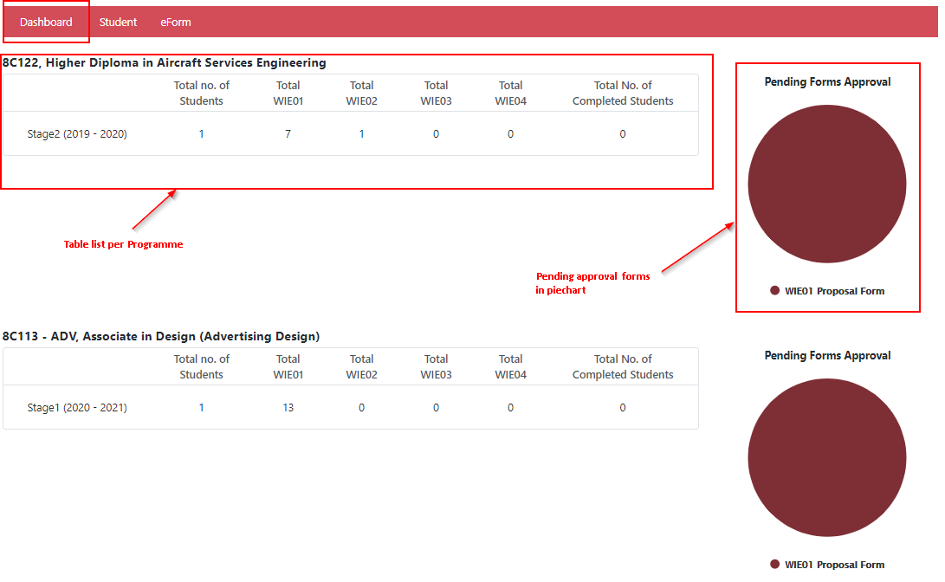
- In the summarized table, the underlined numbers in red are clickable.
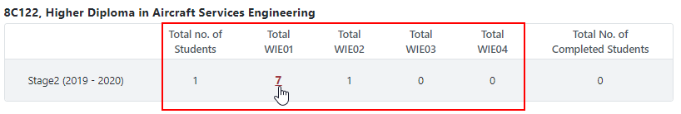

- If you click on the number, it will link to ‘All’ tab under ‘eForm’ view.
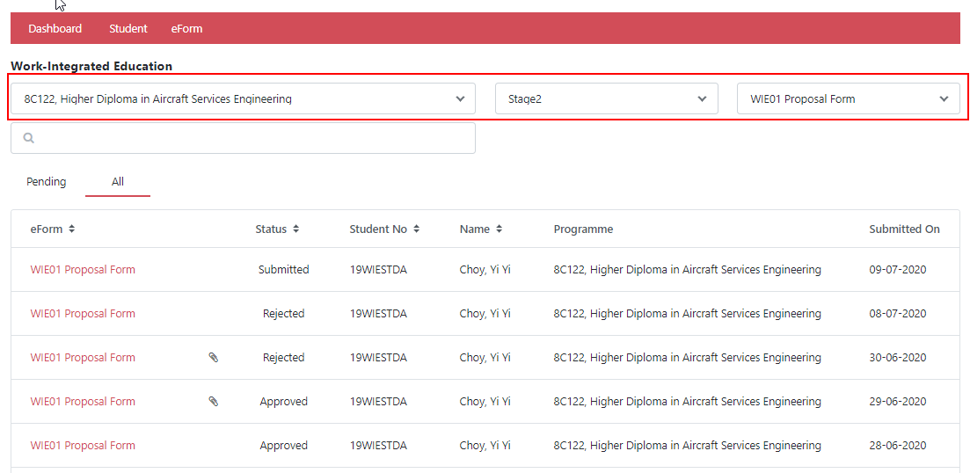

- If you click on a slice of pie chart, it will direct to the ‘pending’ tab under the ‘eForm’ view with designated filtering.
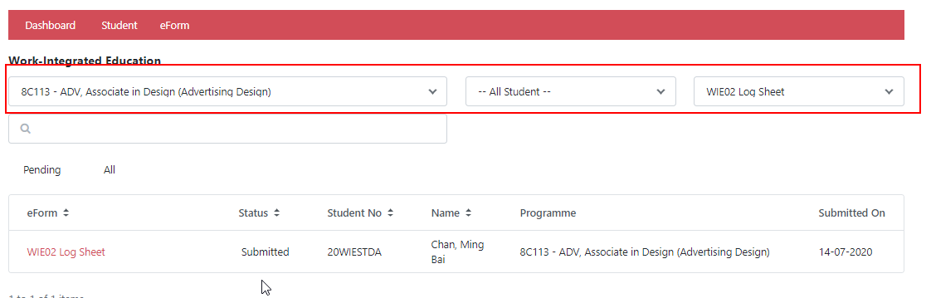

Student
- To access the student view, you can click ‘Student’ at the view navigator.
- The filter selection is placed at the upper panel and the list of student is shown beneath it.
- To search the desired list of students, 4 filtering options are available.
Filter Options | Values
Programme | List of WIE Advisor’s associated programmes
Stage | All Stages  Stage 1  Stage 2  Stage 3  Stage 4
Completion % | WIE hours completion (%) from 0 to 100
Keyword | To input student number & name , programme code & title

For example, if you want to look for the students fulfilling the percentage of completion 20-60%, please adjust the slide bar to that value range.
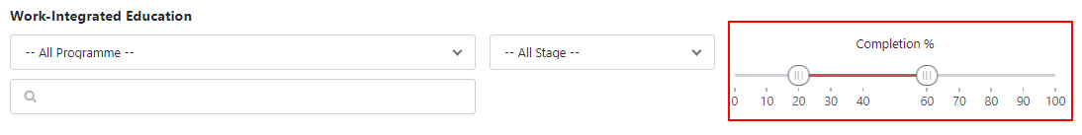

Then, the list of designated students will be updated accordingly.

- To view the student details, please click on the student name.

- Then, the detail of the student will be displayed

- To send individual email to particular student(s), please click the ‘envelope’ icon below.
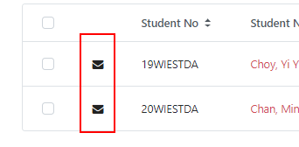

- You can send emails using either a customized template or write a new mail.
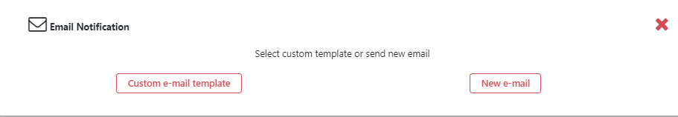

- If you want to create a new message, please click ‘New email’ button. A blank message will be displayed.
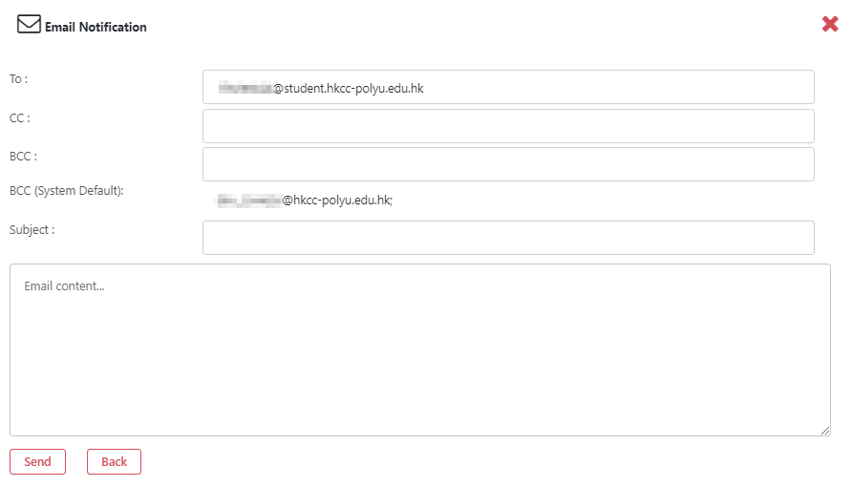

- Please input the subject and message content.

- Then, click ‘Send’ button to send the email. Otherwise, click the ‘Back’ button to go back to the previous screen.

- If you want to draft an email from a message template, please click ‘Custom e-mail template’ button

- The list of custom mail templates is prompted. Please select one of them to continue.
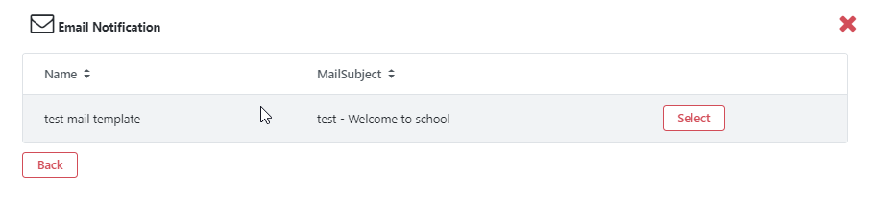

- A customized message will be shown. Please update the subject and message content if needed. Then, click ‘Send’ button to send it.
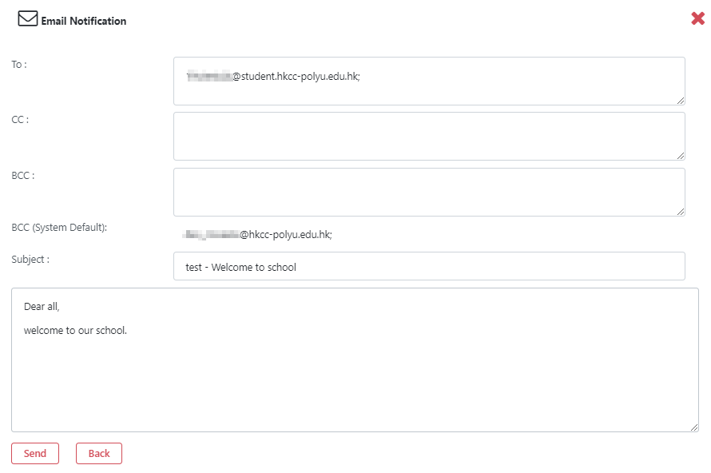

- To send a message to multiple recipients, please check the individual checkboxes and then click ‘Bulk Sent’ button
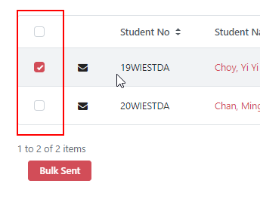

- Repeat the step vii to step xiii if you want to send other messages.

eForm
- To access the eForm view, you can click ‘eForm’ at the view navigator.
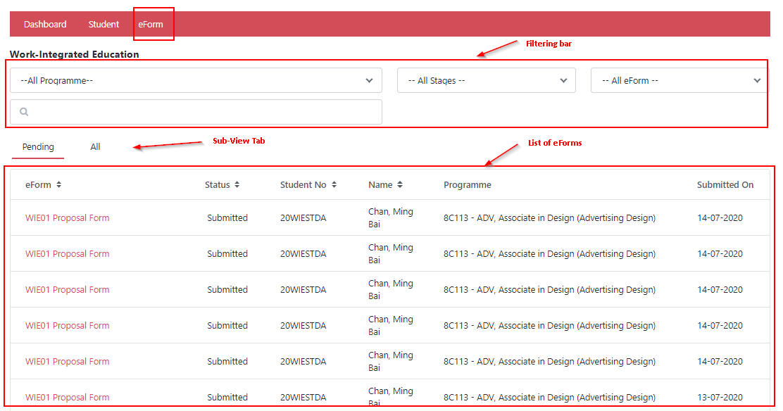
- The filter selection is placed at the upper panel, sub-view tabs is in the middle and the list of eForms is shown at the bottom.

- To search the desired list of eForms, 4 filtering options are available.
Filter Options | Values
Programme | List of WIE Advisor’s associated programmes
Stage | All Stages  Stage 1  Stage 2  Stage 3  Stage 4
WIE Form | All Forms  WIE01 Proposal Form  WIE02 Log Sheet  WIE02 Reflective Learning Statement  WIE04 Prior Work Experience
Keyword | To input student number & name , programme code & title

For example, if you want to look for the stage 2 students, please select ‘Stage 2 …’ in the filtering.
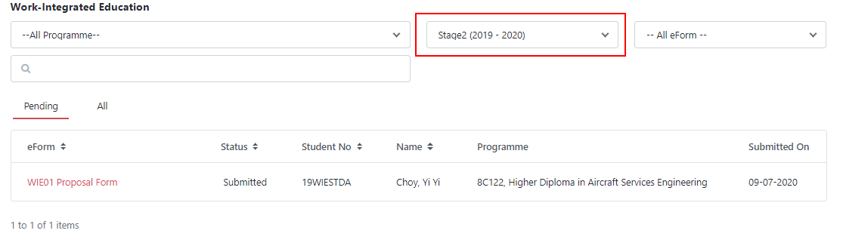

Then, the list of students will be updated accordingly.

You can also switch between ‘Pending’ and ‘All’ view in the sub-view tab under the same filtering criteria.

- To view WIE Forms, please click on the form name.

- Then, this WIE form will be opened and then you will take appropriate actions.

Approve / Reject WIE Forms

WIE01 Proposal Form
- You can open a submitted WIE01 application, then you can review the details in the application form to see whether it can be approved.

- If the application is acceptable, please mark the ‘Approved’ checkbox and then input the effective date. Student’s eligible WIE Hours will only be counted starting from this effective date.
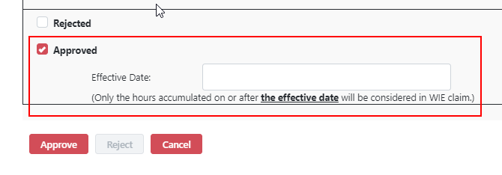

- Then, click the ‘Approve’ button and the application status will be updated to ‘Approved'

- In case that the application form is not acceptable (e.g. with missing supporting documents), you may mark the ‘Rejected’ checkbox and then provide the reasons for rejection.
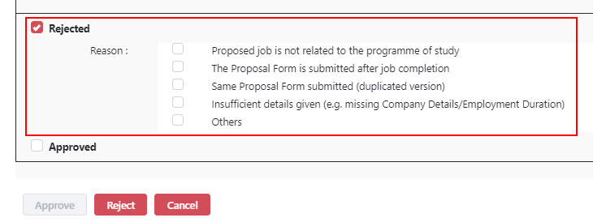

- Then, click ‘Reject’ button and the application status will be updated to be ‘Rejected'.

- A notification message will be sent to that student.
Button | Description
Approve | To approve the WIE application form
Reject | To reject the WIE application form
Cancel | Close without saving

WIE02 Log Sheet
- Open a submitted WIE02 application, you can review each job entry to see whether it is fine.

- If it is acceptable, please mark the ‘Approved’ checkbox. Otherwise, please mark ‘Rejected’ checkbox and then provide the reasons for rejection.
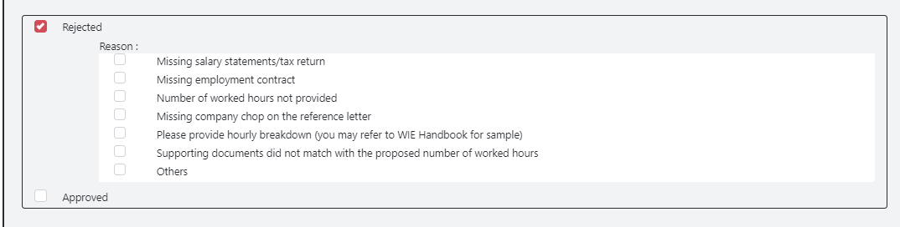

- Once the application is marked Rejected or Approved, please click the ‘Complete’ button to update it.

- A notification message will be sent to that student.
Button | Description
Complete | To complete the WIE application form
Cancel | Close without saving

WIE03 Reflective Learning Statement
- Open a submitted WIE03 application, please review the content of the Reflective Learning Statement to see whether it is fine.

- If it is acceptable, please mark the ‘Approved’ checkbox.

- Then, click the ‘Approve’ button to complete it. The application status will be updated to ‘Approved'

- In case that the application is not acceptable, please mark the ‘Rejected’ checkbox and then input the reasons for rejection.

- Then, click the ‘Reject’ button to complete it and the application status will be updated to ‘Rejected'.

- A notification message will be sent to that student.
Button | Description
Approve | To approve the WIE Reflective Learning Statement
Reject | To reject the WIE Reflective Learning Statement
Cancel | Close without saving

WIE04 Prior Work Experience
- Open a submitted WIE04 application, please review the application form to see whether it is fine.

- If it is acceptable, please mark the ‘Approved’ checkbox, select the type of ‘Recognition’ and input the approved number of recognized WIE Hours as appropriate.
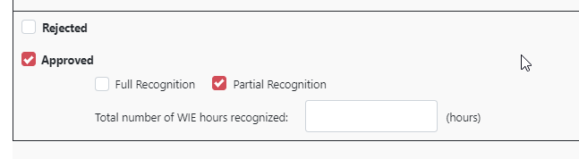

- Then, click the ‘Approve’ button to complete it and the application status will be updated to ‘Approved'

- In case that the application form is not acceptable, please mark the ‘Rejected’ checkbox and then input the reasons for rejection.
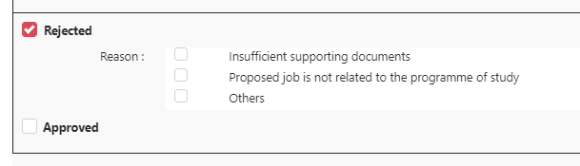

- Then, click ‘Reject’ button to complete it and the application status will be updated to ‘Rejected'.

- A notification message will be sent to that student.
Button | Description
Approve | To approve the Prior Work Experience
Reject | To reject the Prior Work Experience
Cancel | Close without saving

As ‘Office Admin’

Landing Screen
Once login successfully, the office admin landing screen will be shown as below.
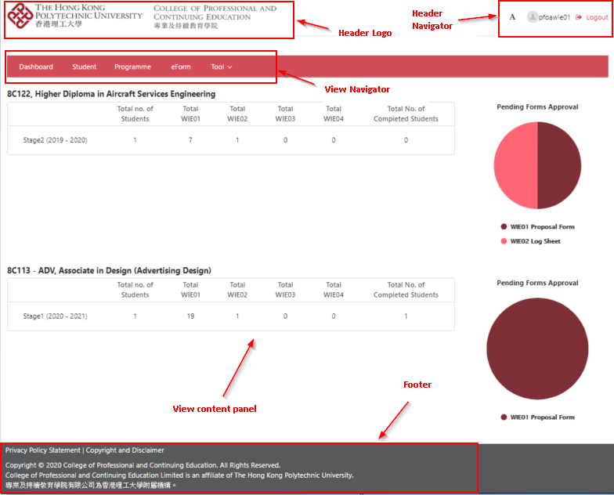
Header Logo | Logo of The Hong Kong Polytechnic University and The College of Professional and Continuing Education are displayed.
Header Navigator | To change font size, office admin’s name and logout.
View Navigator | To navigate the dashboard, student, programme and eForm view content. Tool menu is included.
View Content Panel | To display the associate view content
Footer | To state the privacy policy, copyright and disclaimer.

Header Navigator

Changing the font size
- To click the icon, the pulldown menu is shown.
- You may change the font size by clicking the ‘Small’ or ‘Large’ option.

Logout WIE System
To click for signing off the WIE system.
Once signing off successfully, the below screen will be shown. For security reasons, please close all browser windows.

View Navigator
There are 4 view navigators, Dashboard, Student, Programme and eForm. Also, Tool menu is included.

Dashboard
- To access the dashboard, please click ‘Dashboard’ in the view navigator.

- A summary of the submission status in the programme will be shown in the left panel and outstanding approval forms will be shown in the right panel as pie chart.
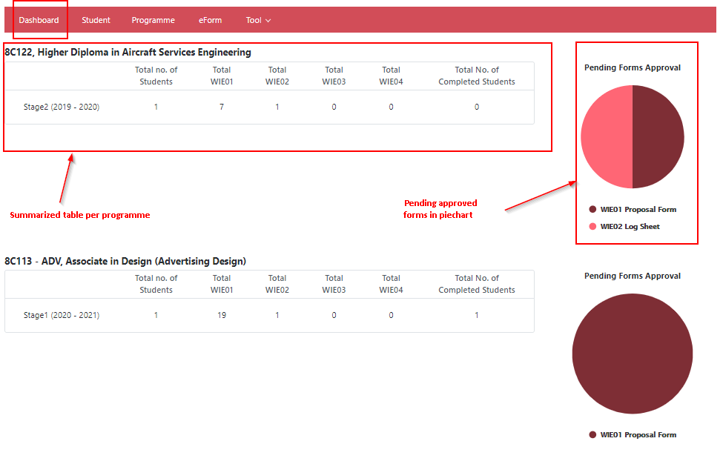
- In the summary table, the underlined numbers in red are clickable.

- If you click on the number, it will direct to ‘All’ tab under ‘eForm’ view.
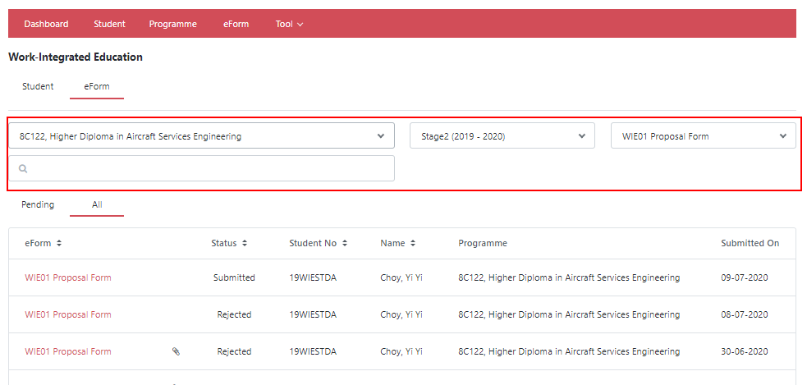

- If you click a slice of pie chart, it will direct to ‘pending’ tab under ‘eForm’ view with designated filtering.
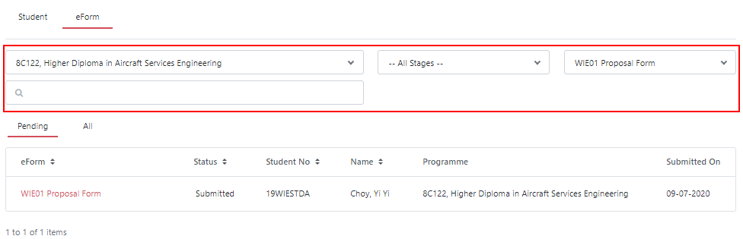

Student
- To access the student view, you click ‘Student’ at the view navigator.
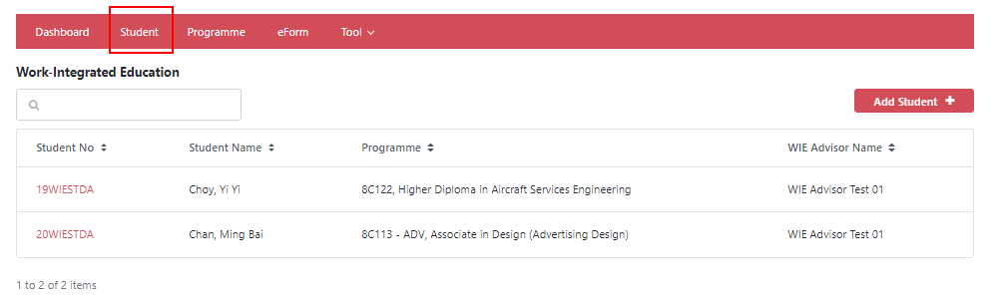
- The filter selection is placed at the upper panel and the list of student is shown beneath it.

- To search the desired list of students, keyword search for student number & name, programme code & title are available.

- To view the student information, please click on the student number.

- Then, the student information will be shown.
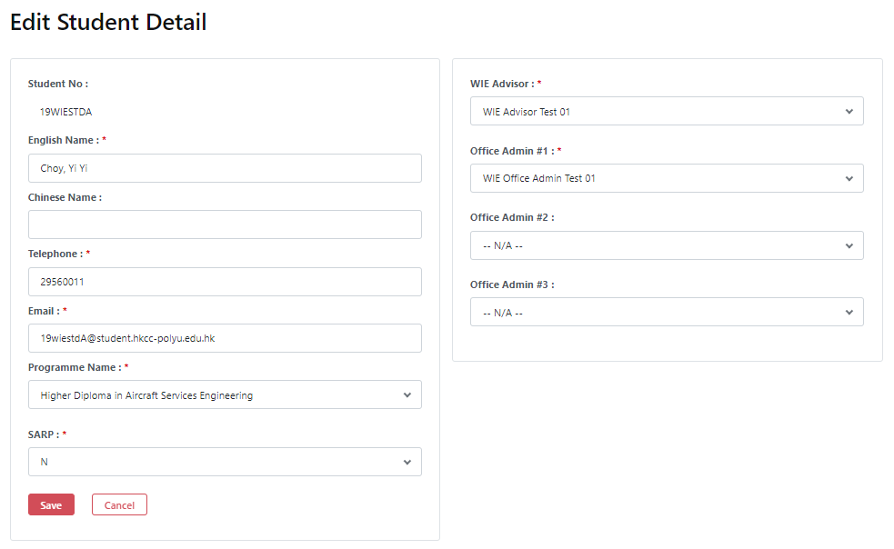
- Please amend the student information if needed. Afterwards, click the ‘Save’ button to update it.
- To add a new student information, please click  button to open a blank form, input all mandatory fields and then click the ‘Save’ button.

Programme
- To access the programme view, click ‘Programme’ at the view navigator.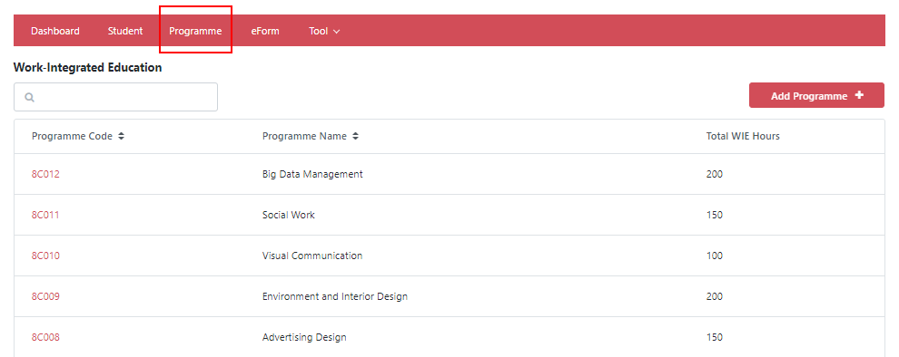

- The filter selection is placed at the upper panel and the list of programme is shown beneath it.

- To search the desired list of students, keyword search, for programme code & title, are available.

- To view programme information, please click a link of programme code.

- Then, this programme information will be shown.
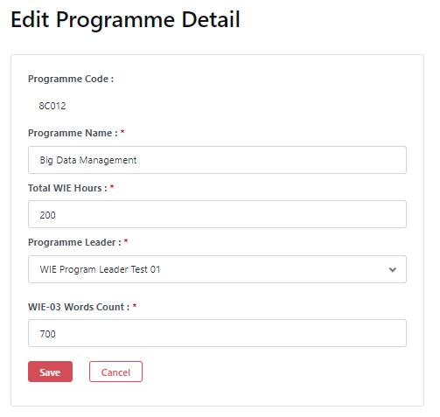

- Please amend any information if needed. Afterwards, click the ‘Save’ button to update it.

- To add a new programme information, please click button to open a blank form, input all mandatory fields and then click the ‘Save’ button.

eForm
- To access the eForm view, click ‘eForm’ at the view navigator.
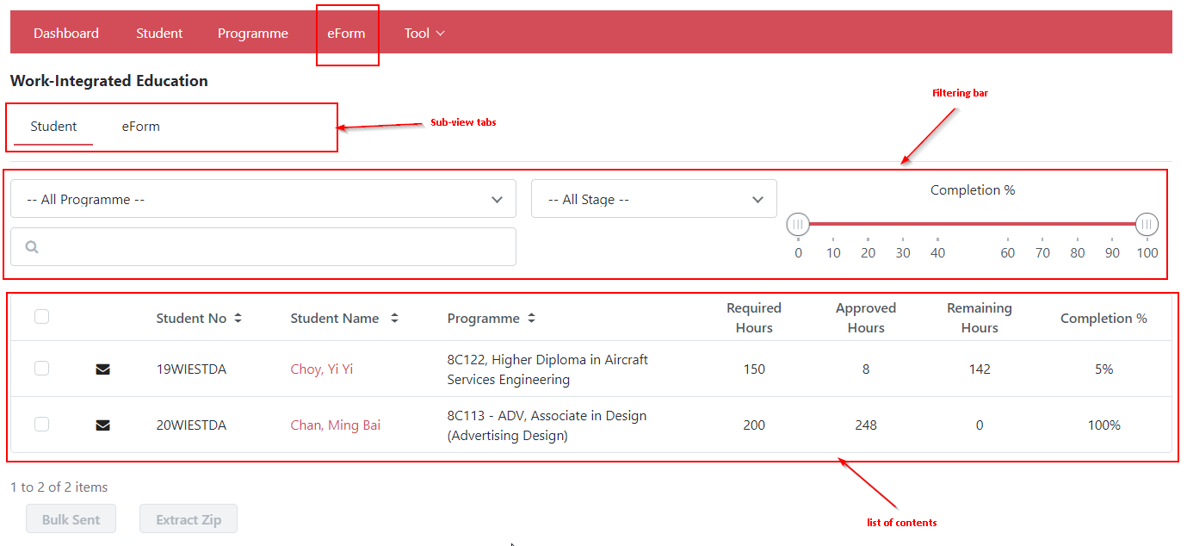

- There are 2 kinds of sub-views, Student and eForm. Both of them have their own filter selection and the list of content is shown at the bottom.

‘Student’ Sub-view

- All submitted WIE application forms are categorized by student number in this view.

- To search the desired content, 4 filtering options are available.
Filter Options | Values
Programme | List of available programmes
Stage | All Stages  Stage 1  Stage 2  Stage 3  Stage 4
Completion % | The range of percentage of completion of WIE hours
Keyword | To input student number & name , programme code & title

For example, if you want to look for the stage 2 students, please select ‘Stage 2 …’ in the filtering.

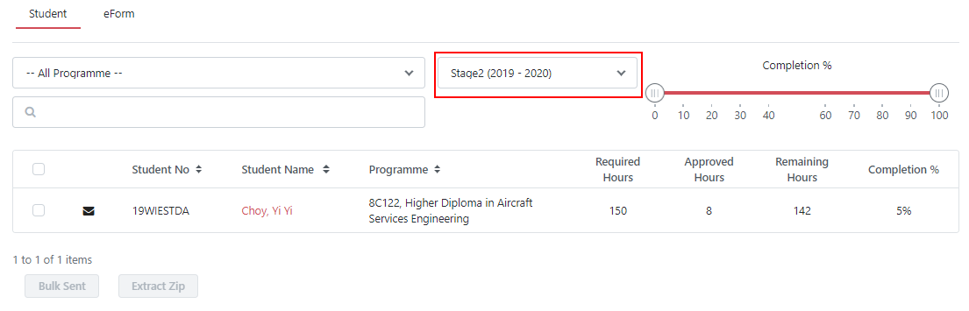

Then, the list of students will be updated accordingly.

- To view the details of the student, please click on the student name.

- Then, this student’s information will be shown and then you will take appropriate actions.

- Click ‘Cancel’ button to go back to the previous screen

- To send individual email to the student(s), please click the ‘envelope’ icon before student number

- Then, please select the type of message either from customized template or a new mail.

- If you want to create a new message, please click ‘New email’ button. A blank message will be prompted.

- Please input the subject and message content.

- Then, click ‘Send’ button to send. Otherwise, click the ‘Back’ button to go back to the previous screen.

- If you want to create a message from a template, please click ‘Custom e-mail template’ button

- The list of custom mail templates is prompted. Please select one of them to continue.

- A customize message will be shown. Please update the subject and message content if needed. Then, click ‘Send’ button to send it.

- To send message to multiple recipients, please check the checkboxes before student number and then click the ‘Bulk Sent’ button
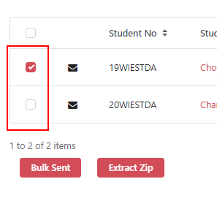

- Repeat the step vii to step xiii if you need to send other messages.

- To extract student WIE form and attachment into a compressed file, please check the checkbox before student number and then click ‘Extract Zip’ button

- Please input the password (case-sensitive) for encryption. This is the password you will need when you open the ZIP file later.

- You may need to wait for a while when the files are being compressed.

- Once it is completed, a message will be shown and the compressed file is ready for download.

‘eForm’ Sub-view

- All submitted WIE application forms are listed by form name in this view.
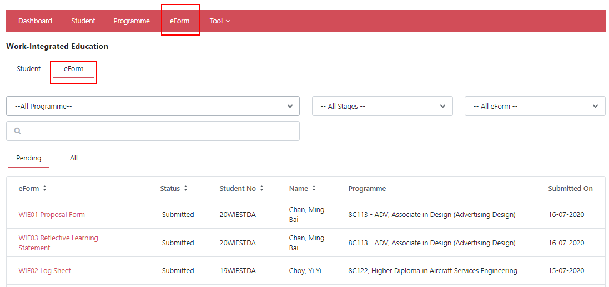

- To search the desired content, 4 filtering options are available.
Filter Options | Values
Programme | List of office admin’s associated programmes
Stage | All Stages  Stage 1  Stage 2  Stage 3  Stage 4
WIE Form | All Form  WIE01 Proposal Form  WIE02 Log Sheet  WIE02 Reflective Learning Statement  WIE04 Prior Work Experience
Keyword | To input student number & name , programme code & title

For example, if you want to look for the stage 2 students, please select ‘Stage 2 …’ in the filtering.
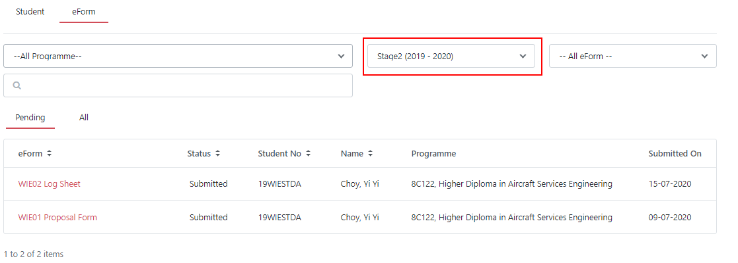

Then, the list of application forms will be updated accordingly.

You can also switch between ‘Pending’ and ‘All’ view in the sub-view tab under the same filtering criteria.

- To view an individual application form, please click on the form name.

- Then, this application form will be opened and then you can take appropriate actions.

- You can click the ‘Cancel’ button to go back to the previous screen

Tool
To maintain and support the WIE application system, there are 4 supportive tasks provided.

Import
To select ‘Import’ option under the ‘Tool’ pulldown menu.
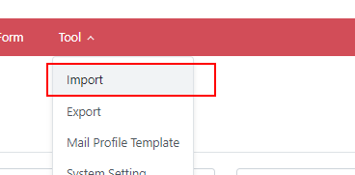

Import Programme-WIE Hours mapping
To maintain the mapping of programme information including programme code, programme title, Programme Leader, required number of WIE hours and minimum words of reflective learning statement in WIE03 form, a pre-defined Excel template should be uploaded (Appendix 6.2)
- To select ‘Programme – WIE hours mapping’ option
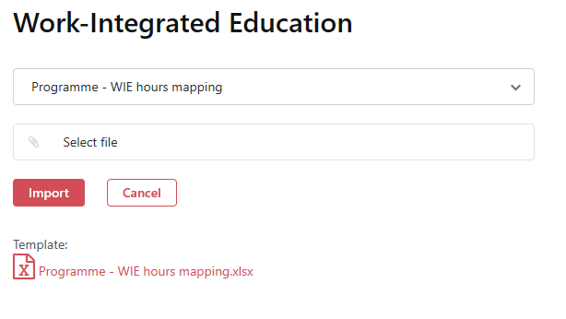
- To choose the Excel file to be imported

- Then click the ‘Import’ button to upload the file

Import Student – Programme mapping
To maintain the information of students and programme, WIE Advisor and office administrative staff, a pre-defined Excel template has to be uploaded (Appendix 6.2)
- Select ‘Student – Programme mapping’ option
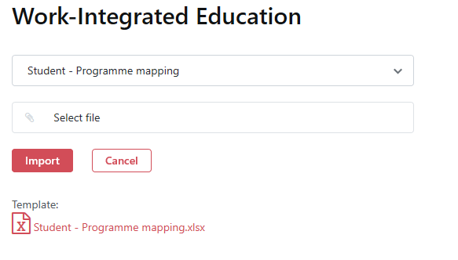
- To choose the Excel file to import

- Then click the ‘Import’ button to upload the file.

Import Student – SARP mapping
The completion of students’ WIE will be confirmed after the SARP meeting in each semester. To mark such status in the system, a pre-defined Excel template has to be uploaded (Appendix 6.2)
- To select ‘Student – SARP mapping’ option
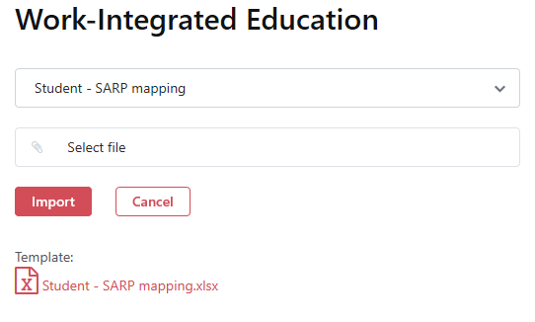
- To choose the Excel file to import

- Then click the ‘Import’ button to upload the file.

Import WIE01 Form Data
To batch import WIE01 application data (for HKCC only), a pre-defined Excel template has to be uploaded (Appendix 6.2).
- To select ‘WIEForm01 Data’ option
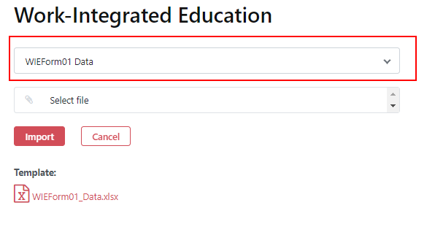

- To choose the Excel file to import

- Then click the ‘Import’ button to upload the file.

Note:
- This importing feature can ‘ADD’ new files only
- It will not check the duplication of files

Export
To select ‘Export’ option under the ‘Tool’ pulldown menu.
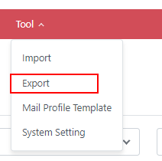

Export Employer Data
- If you want to extract the details of employers, choose ‘Employer Data’ option

- To input the password (case-sensitive) for encryption. This is the password you need to open the file later.

- Click the ‘Export’ button
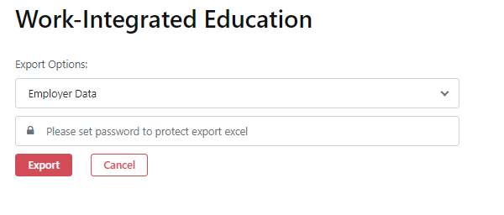

Export WIE Report
- If you want to export the students’ WIE completion status, please choose the ‘WIE Report’ option
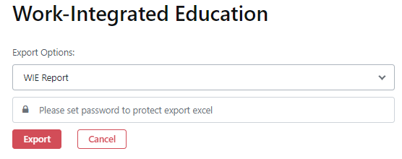
- To input the password (case-sensitive) for encryption. This is the password you need to open the file later.

- Click the ‘Export’ button

Mail Profile Template
- To manage the customised mail templates, select ‘Mail Profile Template’ under the ‘Tool’ pulldown menu.
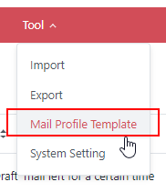

- The list of mail template will be shown.
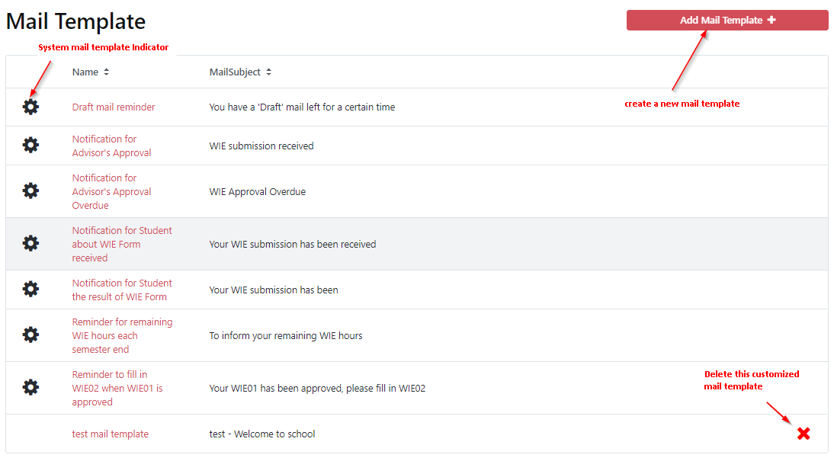

- Click on the mail template name, you can modify its mail subject and content. After that, click the ‘Save’ button to update it

- You can create customized mail template by clicking the icon.

- A blank mail template will be opened. Please input all mandatory fields and save it

- If a customized mail template is no longer needed, you can click the icon to remove it.

Note: System mail template can be modified but cannot be deleted.

System Setting
You can configure the general settings of WIE system such as attachment size and file type:
- Select ‘Tool’ and then ‘System Setting’ option.

- The system setting profile is shown.
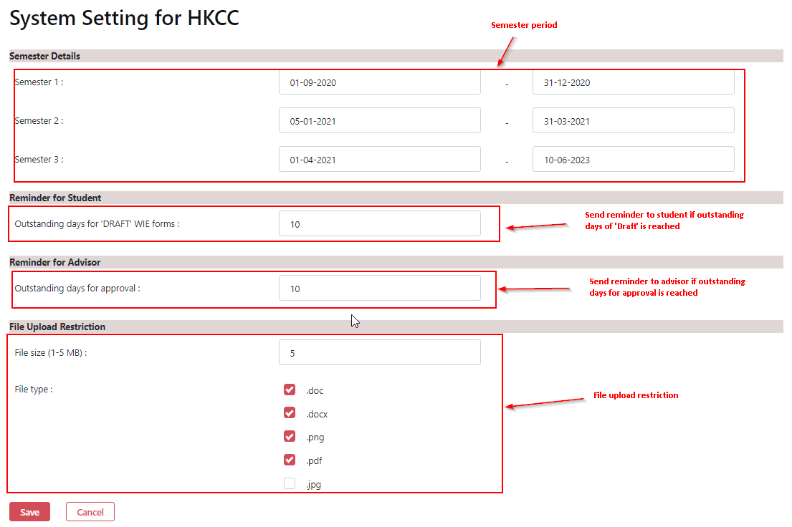

- Please modify the parameters if needed. After that, click the ‘Save’ button to update it.

As ‘Programme Leader’

Landing Screen
Once login successfully, the Programme Leader landing screen will be shown as below.
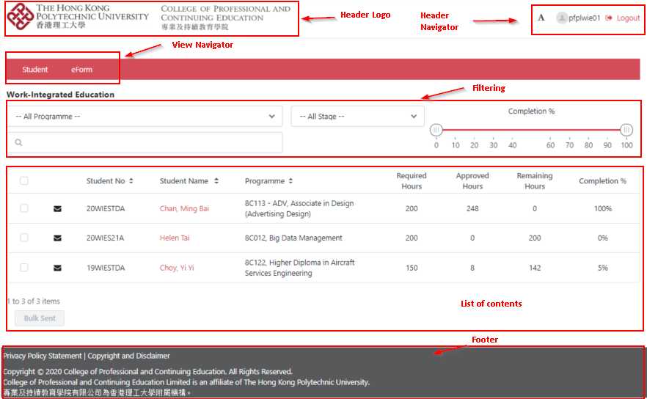
Header Logo | Logo of The Hong Kong Polytechnic University and The College of Professional and Continuing Education are displayed.
Header Navigator | To change font size, WIE Advisor‘s name and logout.
View Navigator | To navigate the student and eForm view content
List of Content | To display the associate records
Footer | To state the privacy policy, copyright and disclaimer.

Header Navigator

Changing the font size
- To click the icon, the pulldown menu is shown.
- You may change the font size by clicking the ‘Small’ or ‘Large’ option.

Logout WIE System
To click for signing off the WIE system.
Once signing off successfully, the below screen will be shown. For security reasons, please close all browsers windows.

View Navigator
There are 2 view navigators, Student and eForm.

Student
- To access the student view, you can click ‘Student’ at the view navigator.
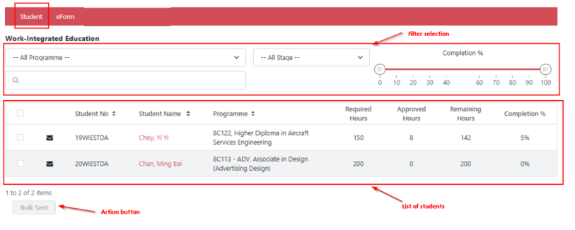

- The filter selection is placed at the upper panel and the list of student is shown beneath it.

- To search the desired list of students, 4 filtering options are available.
Filter Options | Values
Programme | List of WIE Advisor’s associated programmes
Stage | All Stages  Stage 1  Stage 2  Stage 3  Stage 4
Completion % | WIE hours completion (%) from 0 to 100
Keyword | To input student number & name , programme code & title

For example, if you want to look for the students fulfilling the percentage of completion 20-60%, please alter the slide bar to that value range.

Then, the list of students will be updated accordingly.

- To view the student details, click on the student name.

- Then, the student detail will be displayed

- To send individual email to particular students, please click the ‘envelope’ icon below

- You can send emails using either a customized template or write a new mail.

- If you want to create new message, please click ‘New email’ button. The blank message will be displayed.

- Please input the subject and message content.

- Then, click ‘Send’ button to send the email. Otherwise, click the ‘Back’ button to go back to the previous screen.

- If you want to draft an email from a message template, please click ‘Custom e-mail template’ button

- The list of custom mail templates is prompted. Please select one of them to continue.

- A customize message will be shown. Please update the subject and message content if needed. Then, click ‘Send’ button to send it.

- To send a message to multiple recipients, please check the individual checkboxes and then click ‘Bulk Sent’ button

- Repeat the step vii to step xiii if you want to send other messages.

eForm
- To access the eForm view, you click ‘eForm’ at the view navigator.
The filter selection is placed at the upper panel, sub-view tabs is in the middle and the list of eForms is shown at the bottom.

- To search the desired list of eForms, 4 filtering options are available.
Filter Options | Values
Programme | List of WIE Advisor’s associated programmes
Stage | All Stages  Stage 1  Stage 2  Stage 3  Stage 4
WIE Form | All Forms  WIE01 Proposal Form  WIE02 Log Sheet  WIE02 Reflective Learning Statement  WIE04 Prior Work Experience
Keyword | To input student number & name , programme code & title

For example, if you want to look for the stage 2 students, please select ‘Stage 2 …’ in the filtering.

Then, the list of students will be updated accordingly.

You can also switch between ‘Pending’ and ‘All’ view in the sub-view tab under the same filtering criteria.

- To view WIE Forms, please click on the form name.

- Then, this WIE form will be opened and then you will take appropriate actions.

Appendix

Abbreviation and acronyms
The following terms and expressions shall have the following meaning:
Terms | Description
PolyU | The Hong Kong Polytechnic University
The College | The College of Professional and Continuing Education
CPCE | The College of Professional and Continuing Education
SPEED | The School of Professional Education and Executive Development
ITU | CPCE Information Technology Unit
WIE | Work-Integrated Education
WIE01 | WIE Proposal Form
WIE02 | WIE Log Sheet
WIE03 | Reflective Learning Statement of WIE
WIE04 | Recognition of Prior Work Experience

Import Excel Template
Programme - WIE hours mapping

Student - Programme mapping

Students - SARP mapping

WIEForm01 Data

